**SE 362 Project Proposal**

**Travel System**

Ersoy Efe Uruk

Berk Ezircan

**1.Introduction**

Our application is Travel Agency Application. Firstly, application has register and login screen. Above the screen you can login system by using your username and password if you have a registered account. If you have not any account, you can sign up the system in register screen. Register page requires your username, password, email, first name and last name. Also, you can send a message by using the contact form.

Secondly, when you logged in to the system first you can choose your city to travel. Then, you choose the flight company to travel. Moreover, you can choose to date selecting day, month and the year. Also, you can check and select the hours . Finally, you can choose your seat. Also, system provides an optional choice that is you can rent a car or not.

Thirdly, system has an admin login screen. Admin has own username and password. When you make the admin entrance, admin logged in the admin options page. In this page admin can see the all reservations, all users, delete reservations and it can delete an user.

**2. Activity Diagram**

**I)User Activity**

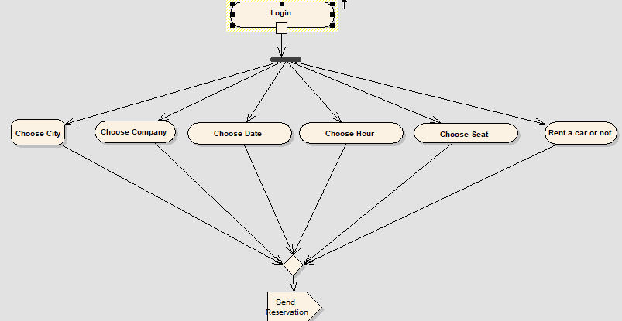

**II) User Register**

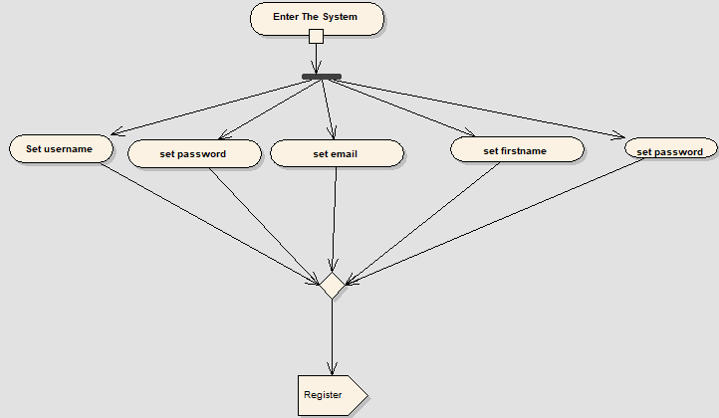

**III) User Login and Admin Login**

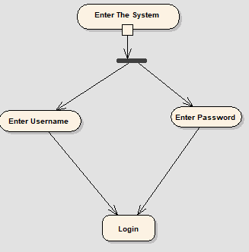

**IV) Admin Activity**

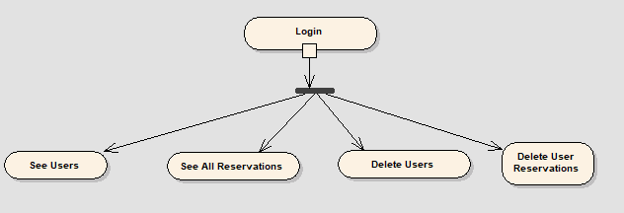

**3.Sequence Diagram**

**User**

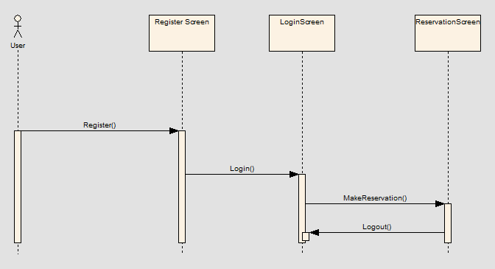

**Admin**

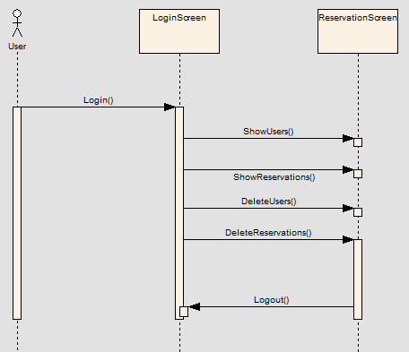

**4.Screens**

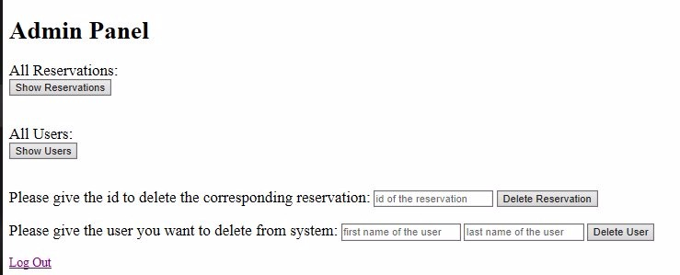

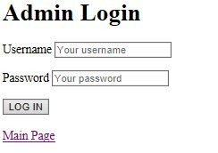

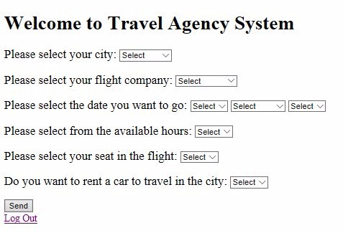

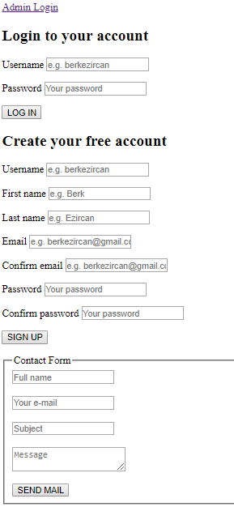

**5. Tables**

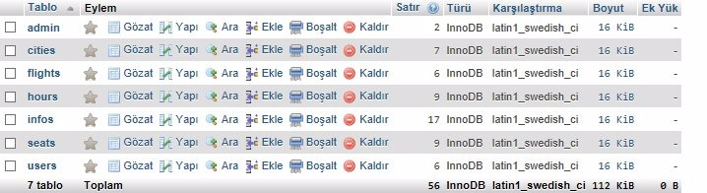

**i)Reservations**

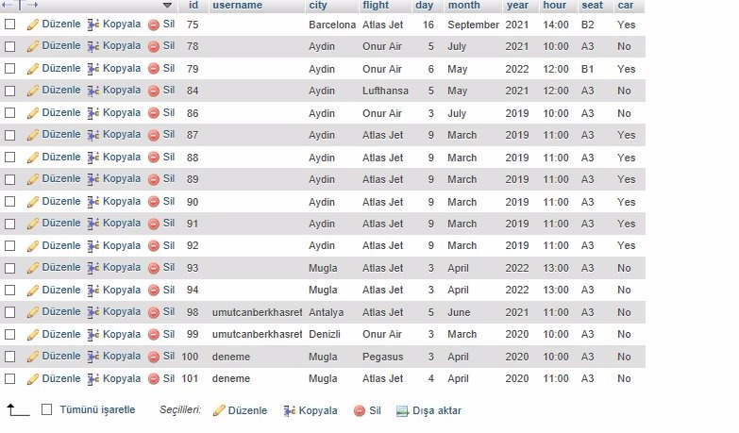

**ii)Seats**

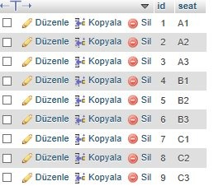

**iii)Users**

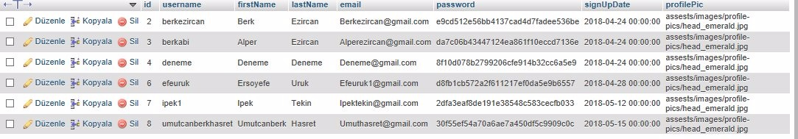

**iv)Admin**



**v)Cities**

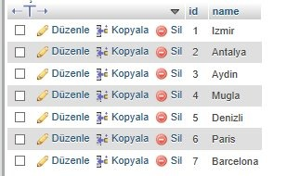

**vi)Flights**

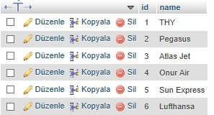

**vii)Hours**

